UBC Press Manuscript Submission Package

This package contains forms that must be completed and submitted with your final manuscript and artwork. Please complete the Manuscript Submission Checklist, the Book Information Form, and (if required) the Text and Data Permissions Inventory Form and the Artwork Inventory Forms.
Please do not use Dropbox or similar cloud-based file-hosting services to submit your manuscript package. Instead, use the OneDrive link sent to you by your acquiring editor.
Detailed information is provided following the various forms to help you with any questions you might have about preparing your manuscript, artwork, and permissions for the Press.
Please contact your acquisitions editor if you have any questions.
Contents

Part 1: Forms_Toc58415774
UBC Press Manuscript Checklist 1
Book Information Form 4
Text and Data Permissions Inventory Form 7
Artwork Inventory Form 8

Part 2: Guidelines
Formatting Requirements 9
Sample Permissions Request 13
Sample Interview Consent Letter 15
Documentation Guidelines 16
Permissions Guidelines 20
Artwork Guidelines 24
Alt-Text Guidelines 28

UBC Press Manuscript Checklist
Add an [X] to indicate your agreement with the following items. Leave blank if not applicable. If something is outstanding, add a comment at the bottom of the applicable section (with an expected arrival date).

Agreements
[ ] I have signed and returned my contract to my acquisitions editor.
[ ] For collections: My contributors have signed and returned their contributor agreements.

Book Information Form
[ ] I have filled out this form, below, or have already sent it separately to my acquisitions editor.

The Text
[ ] I am submitting the complete and final version of my manuscript with all “tracked changes” accepted and other revision marks removed.
[ ] The text is being submitted in a single Word document with section breaks between chapters and paragraphs indicated with an indent.
[ ] Levels of headings (for headings and subheadings) are distinguished clearly, using Word’s “Styles” system.
[ ] Quotations of more than 60 words are set as block quotes.
[ ] Notes are embedded in the text using Word’s “Insert Footnote” function.
[ ] Documentation is in Chicago style, either (1) the author-date system, which includes in-text citations and references, or (2) numbered notes and a bibliography. Most law books are in McGill legal style. See our Documentation Guidelines, below, for more information.
[ ] Tables are created using Word’s table feature (not tabs) and are embedded in the text near where they occur. They are no more than five columns wide.
[ ] Figures (graphs, maps, photographs, or line drawings) are not embedded in the text but are provided in a separate “Illustrations” folder as image files, and named according to their figure number, e.g., Figure 2.1.
[ ] Insertion points (call-outs) for figures are indicated in text and match the file names of figures submitted, e.g., <Insert Fig 2.1>.
[ ] If an edited volume, a list of contributors is included.
Please add any additional comments here.

Text and Data Permissions
[ ] I have read and understood UBC Press’s Permission Guidelines, below.
[ ] I understand that I am responsible for obtaining permission for the use of material (text or illustrations) copyrighted by others for both print and electronic editions of my book.
[ ] I have secured all permissions and have documentation for all copyrighted material appearing in my book, and I have filled out the Text and Data Permissions Inventory Form, below.
[ ] I have in my possession consent forms for any interviews I conducted during the course of my research, and I have completed the interview consent letter for the Press indicating this, below.
Please add any comments here.

Artwork
[ ] I have finalized all artwork, captions (including source and credit information), and alt-text.
[ ] I have submitted finished artwork in accordance with UBC Press specifications as outlined in the Press’s Artwork Guidelines, below.
[ ] I have filled out the Artwork Inventory Form, below.
[ ] I have secured all permissions for copyrighted artwork and noted any credit lines or limitations in the Artwork Inventory Form, below.
[ ] I have provided documentation and/or licences obtained to use copyrighted artwork in my book.
Please add any comments here.

Alt-Text
Select one:
[ ] I have provided alt-text for my images according to the Press’s Alt-Text Guidelines, below.
[ ] I would like UBC Press to hire an alt-text writer at my cost. Alt-text writers will charge between $8 and $15 per image, depending on the complexity of each. This amount will be invoiced to you upon completion of the alt-text.

Index
Select one:
[ ] I will create the index myself, following guidelines set out by my production editor. Please note that this process should not begin until your editor tells you.
[ ] I would like UBC Press to hire an indexer at my cost. Indexers usually cost around $6 per indexable page and this amount will be invoiced to you upon completion of the index.
Please add any comments here.

Chargebacks
Please indicate below to whom UBC Press should send invoices for any costs related to the index, tables, images, alt-text, etc.
Full Name
Address
Contact information

Book Information Form
Now that your manuscript has been approved for publication, we need some information to insert into various bibliographic databases (including Cataloguing-in-Publication and our website) and for our Marketing Department to start promoting your book.
Working title and subtitle of your book:

Author/Editor Information
Please copy and paste this section for each author or editor.
- Name:
  - In full, including any middle names:
  - As you wish it to appear on the title page and cover of your book:

- Citizenship:

- Date of Birth:

- Contact Information:
Please provide your preferred contact information (home or institution). If you are planning any extended travel before or within a year after the release of your book, please provide us with alternative contact information if you will not be available by email. Also, after your book is published, please be sure to update your address for your home or office should you move so that correspondence (including royalty statements) can continue to reach you.
  - Full mailing address (including street and postal code):

  - Telephone (office and/or home and/or cell):

  - Email:

- Publishing History:
This is my first book: [ ] yes [ ] no

If you have previously published a book or books, please provide the bibliographic details (add rows as needed).
Title (main and subtitle) | Author(s) or Editor(s) | Publisher | Year | ISBN

- Author Bio:
Please provide:
  - A one-line statement indicating your present position, occupation, or academic affiliation to be used in your author bio in advertising copy for your book:

  - A fuller description, including your significant publications, awards, and prizes, and other affiliations or past positions of relevance:

Book Description
The descriptions you provide below will serve as the basis for marketing materials.
- In order of importance, please describe the main audiences for your book.

- What are the main subject areas of your book, in order of relevance?

- Please provide two blurbs, as per the specifications below, making them as accurate, accessible, and relevant as possible. Be sure to keep your audiences in mind. Avoid specialized terminology and overly lengthy sentences and use concrete examples where possible. The copywriter will prepare a suite of descriptive copy for promotional material, which will be read not only by experts in your field but also by booksellers, reviewers, and librarians.

  - Following the model below, write a 200-word description of your book that follows this format:
    - First paragraph: Say why your book is important. This is your elevator pitch: why should someone read your book?
    - Second paragraph: Provide a brief description of the content of your book, expanding on the elements highlighted in the first paragraph.
    - Third paragraph: Provide a strong closing synopsis of your book, including your conclusions.

  - Please provide a succinct, snappy one-line description of your book that distills its essence.

- Please list some related or competing titles from other publishers (including author, title, publisher, and publication date).

- How does your book stand out from others on the topic?

- If your book is a new edition, please outline any changes from the previous edition.

- Please list all languages that appear in your book, aside from English.

Cover
- The designer and the marketing department, in consultation with your editor, will decide on the cover design for your book. Any suggestions and likes and dislikes noted here will be taken into account. Please take a moment to offer ideas for images that would be appropriate for the cover; list a book or two with covers you like (not restricted to UBC Press titles); or point out visual themes that may seem obvious but are not appropriate for the cover.

Text and Data Permissions Inventory Form
- Fill out this form if your manuscript contains any of the following (see our Permissions Guidelines, below, for more information):
  - Lengthy text excerpts from other sources (more than 300 words of prose, or more than 4 lines of poetry or lyrics)
  - Quoted material from interviews
  - Substantial sections of your own work that have been published elsewhere.
- Note that permissions for artwork should be indicated on the Artwork Inventory Form, below
- Copyright holders must agree to grant permission to reproduce the material in all editions and formats related to this book, including electronic, for the duration of the publication, and in marketing materials promoting the book (see the sample Permissions Request Form, below)
Type (text excerpt, interview, or previously published material) | Short description | Permission received? (yes/no/not necessary) | Credit line | Any restrictions or stipulations? (if yes, please supply) | Copy of permission document provided? (yes/no)
Please add additional rows as necessary.

Artwork Inventory Form
- Fill out this form if your manuscript contains any artwork.
- Your artwork must meet certain standards and be submitted in the proper format (see our Artwork Guidelines, below).
- If you are unable to meet these standards for graphs, diagrams, or maps, UBC Press can redo this artwork (costs are indicated in our Artwork Guidelines, below).
- If you submit more than 20 photos, you will be charged $20 for each additional photo.
- If you are not able to provide alt-text according to our Alt-Text Guidelines, below, you will be charged between $8 and $15 per image.
- You must seek permission to use artwork that belongs to, or is copyrighted by, others (see our Permissions Guidelines, below, for more information). This permission should include the right to reproduce artwork in all editions and formats of your book, including electronic, for the duration of the publication, and in print and online advertising and other materials promoting your book (see the sample Permissions Request Form, below).
- Please provide copies of permission licences so we can verify that permission has been received, that there are no restrictions, and that the wording in the credit line follows what is stipulated by the copyright holder.
- Please provide alt-text for each image. Alt-text should be written as if you are describing the image to someone who is not able to see it. This is explained more fully in the Alt-Text Guidelines, below.
Figure Number | Type (photo, map, graph, diagram, etc.) | Format supplied (print or digital file; specify file type) | Full caption and alt-text for image | Credit or source | Permissions in order? (yes/no/specify any restrictions)  If yes, provide documentation | Any additional comments? (e.g., cropping, size, layout, modifications needed, etc.)
 |  |  | Caption:
 |  |  | Alt-text:
 |  |  | Caption:
 |  |  | Alt-text:
 |  |  | Caption:
 |  |  | Alt-text:
Please add additional rows as necessary.

Formatting Requirements
These guidelines outline the placement and formatting of elements within the Word file of your manuscript and provide a general overview of artwork and permissions requirements. More detailed guidelines for artwork and permissions are located on our website.
UBC Press generally follows the Chicago Manual of Style (17th ed.), although we are amenable to following styles more specialized to your discipline, e.g., law, anthropology, or natural sciences (please consult your acquisitions editor). Our house guide for spelling is the Canadian Oxford Dictionary.
Make sure that you have sent us the final version of your manuscript and that all “tracked changes” or other revision marks have been accepted as final and that there are no comments, annotations, or hidden text whatsoever in the final version of the manuscript.
The text and any tables should be in single Word document with section breaks between chapters and paragraphs indicated with an indent. You should also provide a PDF file or hardcopy printout as a visual reference copy. Make sure that it matches the final manuscript exactly.

Ordering of Elements
Please put the applicable elements in your manuscript in the following order:
- Title Page
- Dedication
- Table of Contents
- Illustrations List (if applicable)
- Foreword (if applicable)
- Preface (if applicable)
- Acknowledgments
- Introduction
- Book Chapters
- Appendix
- Notes
- Glossary (if applicable)
- Bibliography or References
- Contributors List (if applicable)
- Index

Table of Contents
- A good table of contents provides an important roadmap for your book. It should be clear and concise but also create interest.
- List all part titles and complete chapter titles and subtitles in the table of contents.
- Do not list headings and subheadings in the table of contents.
- Verify that the chapter titles in the table of contents exactly match the titles in the chapters themselves.

Headings
- Heading and subheading levels should be distinguished clearly and consistently (using formatting styles such as caps, bold, or italics).
- Do not number headings.
- The Press uses headline-style capitalization for chapter titles and section headings. Keep articles, conjunctions, and prepositions lowercase, but capitalize the other words in the headings, including the first and last word.
- Do not use “Introduction” as the first heading in a chapter; it is implied that the opening of a chapter will be introductory.
- Do not affix endnote or footnote numbers to headings; these notes should be connected with the relevant text in the chapter (or may appear as an unnumbered note at the beginning of that chapter’s notes when relating to the chapter in general).

Quotations
- Quotations of more than about 60 words should be set off from the rest of the text as extracted block quotes.
- Be sure to copy the exact wording, spelling, and punctuation of quotations. You should also provide full citation information for any quoted material, including the page number.
- Enclose your own interpolations and modifications in square brackets, not parentheses.
- If you have added italics to part of the quotation, note “emphasis added” in brackets at the end of the quotation.
- Poetry passages should appear in the manuscript exactly how you wish them to look in your book: your manuscript should exactly follow the indentation and line breaks of the source. Use tabs to create these indentions, not paragraph styling.

Epigraphs
Epigraphs, or short quotations that set the tone for the text that follows, should appear in only three instances: at the opening of the book, at the beginning of a part, or at the beginning of a chapter. Epigraphs placed elsewhere, such as after headings within the chapter, are discouraged. If they appear at the beginning of chapters, they should be used fairly consistently throughout the book.

Documentation
The Press follows the “Chicago style” of documentation. If you have a strong preference for another style, please consult your acquisitions editor before submitting your final manuscript. The Press will accept an alternate style when deemed appropriate and consistent.
Within the Chicago system there are two main types of documentation: notes and bibliography, which consists of endnotes and a bibliography; and author-date and references, which consists of in-text author/year of publication citations and a reference list at the back of the book. Please make sure you follow one of these styles consistently.
The notes and bibliography style, generally encountered in history and law, gives complete bibliographic information for a work the first time it is cited in each chapter’s notes. These notes may or may not be accompanied by a full bibliography. If you give complete citation information in your notes, a bibliography that merely repeats that information is redundant in that case. You could also consider a selected bibliography, which adds value by imposing a selection process.
In the author-date and references style, sources are cited in the text in parentheses, by the author’s last name, the year of publication, and page numbers if needed; for example, (Brown 1992, 12). This system obviously requires a full bibliography (called References or Works Cited). Discursive endnotes in this system also can include author-date citations.
Footnotes and endnotes should be incorporated into your manuscript using Microsoft Word’s “Insert Footnote” function, not using superscripted note numbers. See more information on how to use this function here.
Please consult our Documentation Guidelines, below, for more information on formatting your citations.

Tables
A table can be an efficient means of conveying information. It should be as simple as possible (no more than five columns wide) and must be understood on its own without reference to the text. Some other things to note:
- Give each table a concise title and provide all relevant source information in a note following the table.
- Use sentence-style capitalization.
- Prepare tables in a word-processing program using the table function, which separates rows into cells rather than being tabbed.
- Unlike figures, tables should be embedded in the body of the principal text files. Put a callout in the text at the end of the paragraph where these items should be placed, e.g., <Insert Table 4>, followed by the table.

NOTE: There will be no charge for the first 20 tables that appear in your book, but the Press generally charges authors $10 per table over that amount.

Text and Data Permissions
It is your responsibility to obtain permission for the use of material copyrighted by others for both print and electronic editions of your book. Because obtaining permission often takes several months and may delay the production of your book, you should start to send out permission requests well before you submit your final manuscript.
Please consult our Permissions Guidelines, below, for specifics on when and how to obtain permissions for copyrighted materials. You can model your permission request on the Sample Permissions Request form, below. It contains the following specific wording that should be used in requesting permission to reproduce an excerpt or illustration: “In all editions and formats related to this book, including electronic, for the duration of the publication, and in print and online advertising and marketing materials promoting the book.”
The completed Text and Data Permissions Inventory Form (for copyrighted text materials), the Artwork Inventory Form (for copyrighted artwork), both above, and all permissions documents indicating that permission has been granted, should accompany the final manuscript.
Please note that even if formal permission is unnecessary, it is incumbent on you to identify the sources of your material. Just as you cite the sources of all direct quotations, so you must cite the sources of tables, maps, figures, and illustrations. You must also acknowledge sources of table and figure data, map data (if you have created maps based on other published sources), and, of course, intellectual debt (original ideas that are not your own).

Artwork
Your final manuscript submission must include all the artwork (photographs, maps, drawings, graphs, or diagrams) that will appear in the finished book. Work on your manuscript cannot begin until the artwork program is complete and you have provided the following:
- finished artwork (in accordance with Press specifications)
- finalized permissions for all artwork
- complete captions, including sources and credit lines
- alt-text for all artwork
- completed Artwork Inventory Form.

Please consult our Artwork Guidelines and our Alt-Text Guidelines for more information on assembling and submitting your artwork. Authors who would like the Press to assess the suitability of potential images for inclusion, especially before purchasing images from an archive, are encouraged to contact their acquisitions editor as early as possible.

Index
Indexes are mandatory for all books and are the responsibility of the author or volume editor. The index is drafted at the first-proof stage of the typeset manuscript. You can do the index yourself or have UBC Press hire a professional indexer on your behalf at a cost of about $6 per indexable page (to be charged back to you after you approve the draft index). Please let your acquiring or production editor know what you would like to do before the manuscript goes into editing.

Sample Permissions Request
Please use this form for requesting permission for text, data, and illustrations.
Dear [copyright holder]:
I am requesting your permission to reproduce material in a forthcoming book by [author/editor name], tentatively titled [book title], to be published by the University of British Columbia Press in [month and year].
The source information that I have for this [excerpt/illustration] is as follows:
[For an excerpt, give the author, complete title, complete publication details for the journal or book in which the excerpt appeared, including page numbers. Include the first and last few phrases of the passage and indicate the total number of words.]
[For a photo, give the name of the photographer and a brief description of the subject of the photograph, or (where applicable) the creator and title of the work shown in the photograph. For another type of illustration, such as a map or a diagram, or for a table, give complete source information as for a text excerpt, along with a brief description and the name of the creator, if known.]
I am enclosing/attaching a copy of the [excerpt/illustration]. <Do this if possible.>
I am requesting permission to reproduce the [excerpt/illustration] in all editions and formats related to this book, including electronic, for the duration of the publication, and in print and online advertising and marketing materials promoting the book. <It is vital for you to ask for all of these things.>
The University of British Columbia Press is a non-profit, academic publishing house. My book is a scholarly study that will be published in an edition of fewer than 800 copies. It will be sold primarily to libraries and scholars.
I also request permission to reproduce the illustration on the cover of the book. <Only include if applicable.>
Full credit will be given to you as the source. If you wish to specify the exact wording of the credit, please do so in your response, using the form box below.
Your prompt consideration is greatly appreciated. If you have any questions, please call me at [phone number] or email your query to [email address]. If you are not the copyright holder, please supply the name and contact information of that person (if known).
Yours sincerely,
[your name]
I/we grant permission requested on the terms stated above.

Name:
Date:
Credit line:
Any restrictions?

Sample Interview Consent Letter
Please use this letter to acknowledge that you retain responsibility to quote from any interviews you may have included in your manuscript. Please do not provide the Press with any signed consent forms; instead, fill out this letter to assure the Press that you have these in your possession, or that you take responsibility for any liability with respect to interviews.
[AUTHOR NAME]
[Author address]
[ACQUISITIONS EDITOR’S NAME]
Acquisitions Editor
And
Nadine Pedersen
Editorial Coordinator
UBC Press
University of British Columbia
2029 West Mall
Vancouver, BC V6T 1Z2
[DATE]
Dear [Acquisitions editor’s name] and Ms. Pedersen:
If you have waivers, use this paragraph:
This letter is regarding the interviews cited in my manuscript, submitted [date], and forthcoming book publication with the University of British Columbia Press, provisionally titled [working title]. I have obtained written permission to quote from interviewees [or their parents, if they are underage], who were made aware of the possibility of publication at the time of the interview. I am retaining these signed consent forms in my possession and assume full liability in the unlikely event of legal proceedings arising from the material.
If you have no waivers, use this paragraph:
This letter is regarding the interviews cited in my manuscript, submitted [date], and forthcoming book publication with the University of British Columbia Press, provisionally titled [working title]. I assume full liability in the unlikely event of legal proceedings arising from the material.
Sincerely,
[Author Name]

Documentation Guidelines
With the exception of legal books, UBC Press follows the Chicago Manual of Style, 17th ed., which presents two basic documentation systems: (1) author-date and (2) notes and bibliography. In general, the author-date system (which consists of in-text citations and a list of references or works cited) is appropriate for physical, natural, and social sciences, whereas notes and bibliography are appropriate for the humanities, including those in literature, history, and the arts. Keep in mind, however, that the author-date system is more scholarly. If you would like your book to capture the interest of general readers, consider using notes and bibliography to free up the text from intrusive in-text citations.
The Chicago-Style Citation Quick Guide, freely available online, offers excellent examples of how to cite various materials in each system. Make sure that your documentation conforms to the examples in terms of format, capitalization, and punctuation. If your documentation does not conform to the guidelines, the manuscript may be returned to you for further revision.
Certain legal studies books may use McGill style. You can find guidelines for this style here.
In addition to the Chicago guidelines, UBC Press preferences for the two documentation styles are outlined below.

Documentation System 1: Author-Date

In-Text Citations

The syntax and content of the sentence govern the location of the citation. When an author-date citation occurs with a quotation, the citation should follow the author’s name, not the quotation. Keep in mind that your book will have a larger audience than would a dissertation or a journal article, and you can’t assume that readers will be familiar with scholars or their works. Provide the scholar’s first name and a gloss to let readers know who you are citing.
Canadian sociologist Vic Satzewich (2015, 221) argues in Points of Entry that “...”
not
Satzewich (2015) argues that “...” (221).
Satzewich argues that “...” (1989, 221).
Citations with more than one entry should be divided by semicolons (Webber 2012; Iacovetta 2007). Avoid long citations with multiple entries that do not pertain directly to the point being made. If a long citation is unavoidable, consider moving its contents to a note instead.
In in-text citations for four or more authors use “et al.” In the running text, use “and colleagues.”
Dhamoon and colleagues (2019, 236) suggest in Unmooring the Komagata Maru that “…”

References or Works Cited

A reference list, or works cited list, generally contains all and only those works cited in the text. They are presented in alphabetical order by author and, if an author has several works, chronologically from oldest to most recent. If two or more works by the same author share a publication year, the letters a, b, c, and so on are affixed to the date, and they are presented in alphabetical order.

Reference List Samples
Atwood, Margaret. 1970. The Journals of Susanna Moodie. Toronto: Oxford University Press. [book]
–. 1972. Survival: A Thematic Guide to Canadian Literature. Toronto: Anansi.
Baeker, G. 2002. “Sharpening the Lens: Recent Research on Cultural Policy, Cultural Diversity, and Social Cohesion.” Canadian Journal of Communication 27: 179–96. [journal article]
Bakhtin, Mikhail Mikhaillovich. 1981. The Dialogic Imagination: Four Essays. Trans. Caryl Emerson and Michael Holquist. Austin: University of Texas Press. [translation]
–. 2003. “Multiple Multiculturalisms and Charles Taylor’s Politics of Recognition.” In Whither Multiculturalism? A Politics of Dissensus, ed. Barbara Saunders and David Haljen, 35–45. Leuven: Leuven University Press. [book chapter in an edited volume]
Barker, Adam J. 2009. “The Contemporary Reality of Canadian Imperialism Settler Colonialism and the Hybrid Colonial State.” American Indian Quarterly 33 (3): 325–51. http://dx.doi.org/10.1353/aiq.0.0054.
Bennett, Tony. 1990. “The Political Rationality of the Museum.” Australian Journal of Media and Culture 3 (1): 35–55.
–. 2006a. “Culture and Difference: Discourse and Policy.” Paper presented at “Quando la Cultura Fa la Differenza: Patrimonio, Arti e Media Nella Società Multiculturale,” Genova, Italy, November 19-21, 2006. [paper presentation]
–. 2006b. “Exhibition, Difference and the Logic of Culture.” In Museum Frictions: Public Cultures/Global Transformations, ed. Ivan Karp, Corinne A. Kratz, Lynn Szwaja, and Tomás Ybarra-Frausto, 46– 69. Durham, NC: Duke University Press. http://dx.doi. org/10.1215/9780822388296-003.

Documentation System 2: Notes and Bibliography

Notes
We generally follow the practice of including full citation information for each item when it is introduced in each chapter. However, we will consider using short form notes only and a full bibliography if the length of your book is an issue. Make sure that full citation information is provided when a citation is introduced in each chapter. Give the author’s name, a short title, and page number for subsequent citations in the same chapter.
Here are some sample notes from one chapter:
- Priscilla Blower, The Family Business: War and Valour (Oxford: Victoria Press, 1987), 16.
- Ibid., 18. [ibid. used if a note contains exactly the same citation as the preceding note, when that note contains only one citation]
- Ibid. [ibid. without a page number signifies the same page number as the preceding note]
- Theda Skocpol and Margaret Somers, “The Uses of Comparative History in Macrosocial Inquiry,” Comparative Studies in Society and History 22, 2 (1980): 183. [journal article]
- Adam Przeworski, “Methods of Cross-National Research, 1970-1983: An Overview,” in Comparative Policy Research: Learning from Experience, ed. Meinolf Dierkes, Hans N. Weiler, and Ariane Berthoin Antal, 38-59 (Brookfield, VT: Gower, 1987). [book chapter]
- Blower, Family Business, 28. [short title used for second and subsequent citations of a work within a given chapter]
- National Association of Investors Corporation, NAIC Online, 20 September 1999, http://www.better-investing.org. [web-only material]
- Letter from A.L. Jolliffe to J.G. Levy (Private Secretary to the Minister), Library and Archives Canada (hereafter LAC), RG 76, vol. 830, file 552-1-644, pt. 2. [archival material]

Bibliography
Avoid the temptation to break the bibliography into many short parts, such as primary Canadian sources, primary British sources, books, articles, unpublished manuscripts, and so on, which can make it difficult to find a given item. Generally, only the following divisions are necessary, depending upon the discipline and nature of the book:
Archival Sources
Archival sources should be listed alphabetically by archive. Under the name of each archive, list only the name of the record or manuscript groups consulted and the record group or accession number. Do not list each manuscript and document. If you only use a handful of manuscripts or documents from an archival collection, they can be listed separately under “Archival Sources” and alphabetized by document title or author.
Newspapers and Magazines
Only list the names of newspapers or magazines. Do not include individual magazine or newspaper articles.
Legislation and Jurisprudence
The Chicago Manual of Style does not recommend listing legislation and jurisprudence, but they should be listed if the book is in formal legal style (McGill style).
Other Sources
This section should include theses, dissertations, government publications, and all published books and articles (primary and secondary).

Bibliography Sample
Archival Sources
Canadian War Museum Archives, Ottawa (CWM)
May Bastedo fonds, 58A 1 2.1
Gertrude Ellinor Halpenny fonds, 58A 1 46.11
Library and Archives Canada, Ottawa (LAC)
Department of Militia and Defence, RG 9
Records of the Minister of Militia, A. E. Kemp, MG 27 111 D
Margaret Clothilde Macdonald fonds, MG 30 E45
Sophie Hoerner fonds, MG 30 E290
University of British Columbia Archives, Vancouver (UBCA)
Laura Holland fonds
Newspapers
Calgary Herald
Regina Leader
Toronto Star
Washington Post
Other Sources
Acton, Carol. “Diverting the Gaze: The Unseen Text in Women’s War Writing.” College Literature 31, 2 (2004): 53–79. [journal article]
–. The First Contingent to the Autumn of 1915. Vol. 1, War Story of the Canadian Army Medical Corps. Toronto: Canadian War Records Office, 1918. [volume in a multivolume work and published primary source]
Addie, Kate. Corsets to Camouflage: Women and War. London: Hodder and Stoughton, 2003. [book]
Allard, Geneviève. “Caregiving on the Front: The Experience of Canadian Military Nurses during World War I.” In On All Frontiers: Four Centuries of Canadian Nursing, ed. Christina Bates, Dianne Dodd, and Nicole Rousseau, 153–67. Ottawa: University of Ottawa Press/Canadian Museum of Civilization, 2005. [chapter in an edited volume]
Beck, Marie Lanser. “The Early Career of Ellen Newbold LaMotte (1873–1961): World War I Nurse, Author and Anti-Opium Crusader, 1902–1925.” Master’s thesis, Shippensburg University, 1992. [thesis]

Permissions Guidelines
It is the author’s responsibility to obtain permission for the use of material (text or illustrations) copyrighted by others for both print and electronic editions of your book. No production work will begin on your manuscript until you have supplied licences or other documentation for all works requiring permission. Therefore, you are encouraged to identify material that is copyright protected early on in the process, and begin applying for permission as soon as peer review is completed and publication is confirmed.
This document is intended to help you identify when you will need to request permission and thus meet your legal obligations. UBC Press has no power to release you from them. Nor can we offer legal advice; if you are not sure whether a particular course of action might result in a lawsuit, you should consult a lawyer.
UBC Press has developed the following guidelines to help authors determine whether permission is necessary for specific types of material (note that interviews, although rather different in nature from other materials, also require permission to be reproduced). After these basic guidelines we have provided further information on copyright in general, who owns copyright, and the concept of “fair dealing.”
Please note that according to the Canada-United States-Mexico Agreement (CUSMA), ratified in July 2020, copyright protection lasts for a general term of life of the author + 70 years.

What Material Requires Permission?

Text

Prose and poetry excerpts
As a general guide, you should obtain permission for all published and unpublished prose excerpts over 300 words and for poetry excerpts that constitute more than 4 lines of the poem. You also need to obtain permission for documents such as e-mails, letters, speeches, sermons, public addresses, radio broadcasts, and so on. Try to avoid lengthy quotations and to break particularly long ones into parts. Cumulative quotations from a single source should normally not exceed 500 words without permission.

Excerpts from commercial sources
Contemporary literature, song lyrics, and other for-profit material in current circulation can have more stringent requirements. When quoting more than a short phrase from commercial sources, please obtain permission from the rights holder and make sure you discuss this with your editor at UBC Press.

Translations
Published translations are subject to the same permissions requirements as works published in their original language.

Interviews
You must obtain written permission to quote from interviewees who are identified in the text or are potentially identifiable. Anonymous interviewees must have been made aware of the possibility of publication at the time of the interview. If you cannot supply the Press with copies of the signed consent forms (for reasons of privacy), you must provide a letter stating that you have signed consent forms in your possession and that you assume full liability in the unlikely event of legal proceedings arising from the material. Please consult the Sample Interview Consent Letter, above, if you are unsure of what to include in your letter.

Federal government documents
Federal government documents such as laws, statutes, acts of Parliament, court/tribunal decisions, and so on, are not copyright protected and can be freely used without seeking permission. But other Crown documents, such as reports, maps, plans, and so on, are often copyright-protected, and you must obtain permission from the relevant department or ministry. This is the case even in situations where the material is free or made publicly available online, at government offices, and so on.

Provincial/territorial/municipal government documents
The situation varies across the country with respect to government documents of any type, and so any use should be treated as if the material in question is copyright protected, and the appropriate inquiries should be made.

Your own previously published work
You may need to seek permission to use or adapt your own previously published work. Some publication agreements issued by scholarly journals or presses state that the author is free to republish the material in a book of his or her own. But before reprinting your own previously published material or drawing from it in a significant way, review your publication agreement to see what rights you may have transferred to the original publisher.

Illustrations
Note that if the illustration you wish to reproduce was found in a book, it is unlikely that the book’s publisher is the copyright holder. The original source of the illustration can probably be found in the figure’s caption or in a credit section elsewhere in the book.

Photographs
Permission is required for all photographs, and the photographer and/or archive must be properly credited. The copyright owner is the owner of the negative – this may or may not be the photographer. In addition, even if copyright has lapsed and the image in question is now in the public domain, you may have to obtain a licence from an archive to use the photograph. If you have photographed people specifically for the purpose of including their images in your book, you will need to obtain letters of consent from them.

Graphs and tables
For graphs and tables you have conceived of and created yourself, simply credit the source of the data. For graphs and tables that represent intellectual analysis done by someone else, you will need written permission.

Maps
Maps require permission if reproduced from another copyrighted source, including online sources.

Unlocatable Copyright Owners
In situations where you have attempted unsuccessfully to locate the owners of copyright and have exhausted all avenues, please discuss the situation with your editor at UBC Press. Keep a close record of your efforts (phone calls, emails, internet searches, etc.); in some cases we may still be able to use the material in question if it can be established that you have exercised due diligence. If not, we may decide that you should apply to the Copyright Board for clearance.

What Is Copyright?
Copyright is a form of protection provided by the Canadian Copyright Act to the authors of original works of authorship, including literary, dramatic, musical, artistic, and certain other intellectual works. This protection is available to both published and unpublished works. Unless you are able to claim “fair dealing” of a work (known as “fair use” in the United States), you must obtain permission from the copyright holder in order to reprint (or adapt) prose, poetry, tables, figures/graphs, music, song lyrics, line drawings, photographs, fine art, and any other form of copyrightable expression. Note that in general, your published UBC Press book will not fall under “fair dealing” exceptions, and you will be required to adhere to the Copyright Act.
Some key points to remember:
- Copyright applies only to original expressions, not to facts or ideas. The latter are part of the public domain and no one can have monopoly over them.
- Copyright applies to both published and unpublished works.
- For copyright to exist, it must be “fixed” in some tangible form (recorded, written down in some form, created, etc.)
- “Fixation” is all that is necessary for copyright to come into being (i.e., no formalities or registration are necessary). Copyright protection is automatic upon the creation of a work.
- Copyright is always limited in duration, and at the end of the term of copyright the material enters the public domain. Once in the public domain, the exact work can never again be protected and is free for all to use.

Who Owns Copyright?
It is often difficult to ascertain who owns copyright in a particular work. In many cases, copyright is owned by the creator of the work. There are, however, exceptions to this.
- The copyright may have been assigned by the author to another party.
- If the work is created as a part of one’s job in the course of employment, the employer will own the copyright (unless a separate agreement assigning it to the creator is in place).
- In the case of published texts and music, the publisher may administer the copyright on behalf of the author.
- In the case of photographs or fine art, the artist may be represented by a gallery or agency who can grant reproduction rights.
When you begin applying for permissions, do not assume that the author or publisher holds copyright. It is your responsibility to ascertain exactly who the rights holder is and to make the appropriate application. For more information on ownership, please review Section 13 of the Copyright Act. If you have difficulty determining who might own copyright, please contact the Press’s assistant editor, Editorial and Production, Carmen Tiampo, at tiampo@ubcpress.ca for assistance.

Term of Copyright
The general rule stipulates that the term of copyright for most works is the life of the author + 70 years. There are numerous exceptions to this general rule, some of the more common of which are:
- Multiple authors: life of last surviving author + 70 years
- Works owned by Crown: remainder of year of making + 70 years
- Photograph where first owner is individual: life of author + 70 years
- Photograph where first owner is corporation: remainder of year of making + 70 years.
For situations not covered above, please refer to the Copyright Act, contact the Press’s assistant editor, Editorial and Production, Carmen Tiampo, at tiampo@ubcpress.ca, or see one of the works listed under “Additional Resources” below. You could also speak to the copyright office at your university.

Fair Dealing
Section 29 of the Canadian Copyright Act does allow for the limited use of copyrighted material under five basic categories: research, private study, criticism, review, and news reporting. If your use of copyrighted material falls within the bounds of fair dealing, you do not need to seek permission to use that material, although you do need to credit the source and the name of the author/creator. Unfortunately, the Act does not provide much guidance on what exactly constitutes fair dealing or an infringement of copyright.

Additional Resources
For a more in-depth discussion of copyright and permissions as they apply to publishing in a Canadian context, the following sources offer additional information:
Bielstein, Susan M. Permissions, A Survival Guide: Blunt Talk about Art as Intellectual Property. Chicago: University of Chicago Press, 2006 (particularly as it pertains to visual imagery).
Harris, Lesley Ellen. Canadian Copyright Law, 4th ed. Toronto: McGraw-Hill Ryerson, 2013.
Murray, Laura J., and Samuel E. Trosow. Canadian Copyright: A Citizen’s Guide, 2nd ed. Toronto: Between the Lines, 2013.
Vaver, David. Copyright Law. Toronto: Irwin Law, 2000.

Artwork Guidelines
The term artwork refers to a variety of illustrative materials, such as photographs, maps, drawings, graphs, and diagrams. Work on your manuscript cannot begin until the artwork is complete and you have provided the following:
- finished artwork (according to UBC Press specifications)
- complete captions, including sources and credits
- complete alt-text
- finalized permissions
- completed Artwork Inventory Form.
The original illustrations submitted for production must be of publishable quality. The instructions here will guide you through the process of assembling and submitting the illustrations for your book. If your manuscript includes a large number of illustrations, if you have technical questions about reproduction quality or the preparation of any artwork, or if you are concerned about whether you should purchase images before they have been assessed by the Press, please speak to your acquisitions editor. Your editor will request that a member of our production staff assist you. It is best to address potential image and permissions issues as soon as possible to avoid delays when your book is in production.
NOTE: Because maps, graphs, and diagrams are difficult to execute according to proper publishing standards and to match the overall look of your book, UBC Press redraws all maps, graphs, and diagrams. Our rates are very low and the output professional. Examples of redrawn maps, graphs, and diagrams appear at the end of these guidelines.

Photographs
Choose photos for their content and quality, including sharp focus, good contrast, and a range of tone; avoid images with high or low contrast, because the printing process will exaggerate these qualities.
Photographs should be provided as high-resolution digital files or as high-quality prints. Digital files should be provided as TIFFs or JPGs at a resolution of at least 300 dpi (dots per inch) at the final intended print size (generally 5 inches wide). If the photo is going to be cropped, this should be taken into consideration as this would affect the resolution.
The overall size of the digital file is generally a good guide as to its resolution. If a file is smaller than 500 KB, the image is likely low resolution. High-quality grayscale TIFFs are often over 2 MB in size. File sizes for colour images can be significantly larger. If you are unsure, we will be happy to check the files for you.
Avoid providing scans of images from previously printed books and magazines. There is a noticeable reduction of sharpness when these images are rescreened during the printing process. If this type of artwork is unavoidable, provide the original book or magazine for us to scan according to our printer’s specifications.
Indicate any special instructions for the treatment of photos, such as cropping, in the last column of the Artwork Inventory Form.
NOTE: There will be no charge for the first 20 photos that appear in your book, but the Press generally charges authors $20 per photo over that amount.

Line Art
If the image you are scanning is a line drawing with only solid black and white (with no shades of grey), such as a political cartoon, then the resolution must be a minimum of 1200 dpi at 5 inches wide.

Maps
It is very difficult to provide maps to the standard acceptable for publication and to coordinate this with the eventual design of your book. UBC Press works with a professional cartographer who can prepare your maps at a very reasonable cost and to our specifications. Not only will this enhance the look of your book, it will also save you time, as your maps can sometimes be prepared while your manuscript is being edited.
If you would like UBC Press to arrange to have a map prepared, supply a copy of a historically accurate base map with all pertinent locations and features clearly indicated and labeled. This does not have to be high resolution, only readable quality. You should also submit a Word file with labels to be included on the map, grouping them according to type (e.g., names of countries, cities, provinces, rivers, mountain ranges, etc.) and identifying any labels that should receive special treatment or emphasis. You should also provide instructions and text for any required legend.
NOTE: Drafts of the maps will be sent to you to check. When you have approved the final artwork, you will be sent an invoice. The rates are about $250–$350 per map.

Graphs
Graphs are diagrams showing the relationship between variable quantities. It is now common to create graphs in programs such as Word, PowerPoint, and Excel. Graphs created by these programs are fine for use in presentations or when printed on laser printers, but their output does not reproduce correctly on printing presses.
Please supply the Excel, Word, or PowerPoint file and a screenshot of each. To ensure accuracy in representing the data, it is important that you also provide the data files (e.g., Excel sheets) you used to generate the graphs. If there are any special instructions, note them in the Artwork Inventory Form.
If you have created your graphs using specialized graphing software, such as R or Stata, please supply a low-resolution image file of the graph as well as an editable EPS file.
NOTE: UBC Press redraws all graphs at a cost of about $35 per graph.

Diagrams
Diagrams use text and lines to show a general scheme or outline of an object (idea) and its parts. It is recommended that all diagrams be prepared by our typesetter so that they coordinate with the text design of the book and meet our printer’s technical specifications. Please send a rough drawing of what you would like the diagram to look like along with a Word file containing the text that will appear in the diagram (or simply the whole diagram in Word or PowerPoint). Please provide any additional special instructions in the Artwork Inventory Form.
NOTE: The cost to redraw diagrams is typically no more than $25 per diagram.

Tables
Technically, tables are not artwork, but they can be an efficient means of visually conveying information. They should present information as simply as possible and be understood on their own without reference to the text.
Prepare tables in Microsoft Word using the table function, which separates rows into cells rather than being tabbed. A table should be no more than five columns wide.
Give each table a concise title and provide all relevant source information in a note at the end of the table.
Tables should be embedded in the body of the manuscript file. Put a callout in the text at the end of the paragraph where these items should be placed, e.g., <Insert Table 4.1>, followed by the table.
NOTE: There will be no charge for the first 20 tables that appear in your book, but the Press generally charges authors $10 per table over that amount.

Alt-Text
In addition to regular captions for illustrations, the Press requires authors to provide captions in the form of alt-text (alternative text) to make your book more accessible to vision-impaired readers. Unlike a caption, alt-text describes only what appears in the photo, for example:
Three Black men stand on a sloped driveway in a suburb. Behind them a house behind an unpainted wood-slat fence can be seen. Trees line the street. The men are holding hands, their hands raised at chest-height toward the camera, fingers entwined.
NOT
Canada’s reggae champions keyboardist Jackie Mittoo, artist manager Karl Mullings, and guitarist Lynn Taitt.
For more extensive guidelines on alt-text, see the alt-text guidelines, below.

Sending Artwork to UBC Press
UBC Press cannot begin work on a manuscript until the artwork is complete. Before you send your illustrations to the Press, you will need to do the following:
- Make sure your artwork is prepared according to the specifications listed above.
- Number each type of illustration in a separate sequence through the manuscript. Photographs, graphs, and drawings scattered in the text may together be identified as “figures” and numbered sequentially (Fig. 1.2, Fig. 1.3, etc.) according to the chapter and order that they appear.
- Always submit artwork separately from the text (EXCEPT FOR TABLES, which should be embedded in the text), whether you are providing it as hardcopy or in a digital format. The digital image files should be provided separately (never embedded in the text), and the file names MUST include the figure number (see previous point).
- Indicate the approximate placement of each illustration in the manuscript file by inserting a callout between angle brackets, e.g., <Insert Figure 1.1>, plus the caption, at the end of the paragraph that refers to the image.
- Provide a complete caption followed by the credit/source and any special instructions on the Artwork Inventory Form.
- Each caption should include the source of the illustration (unless it was created by the author), e.g., archive, photographer, artist, or any specific credit wording if permission was required to use the illustration. If the figure is a graph, the source for the data should be included.
- Provide complete alt-text, or your best attempt at alt-text. UBC Press understands that this is likely a new process for authors and we will be sending the alt-text to a copy editor along with the rest of the manuscript.
- Fill out the Artwork Inventory Form. This vital document summarizes what you are providing to UBC Press.
- Please provide copies of permission licences so we can verify that permission has been received, that there are no restrictions, and that the wording in the credit line follows what is stipulated by the copyholder.
We will evaluate the artwork and get back to you if there are any problems.
Please find several examples for various kinds of artwork at the end of these guidelines.

Alt-Text Guidelines
Image descriptions, also known as alt-text, are used by screen readers and other adaptive software to allow blind, low-vision, or people with other disabilities to understand non-text content. Alt-text does not appear visibly in the text. Captions, on the other hand, appear below the image and do not have to closely mirror what appears in the image; instead, alt-text should describe how the image relates to the surrounding text.
NOTE: if you are unable to provide alt-text for each image, you will be charged between $8 and $15 per image to cover the cost of hiring an alt-text writer.

General Considerations
Descriptions for the same image may differ vastly depending on context. Survey the text surrounding an image to understand how it fits into the bigger picture. Use context to decide which concepts and terms have already been explained and avoid repetition of explanations and the sharing of irrelevant information. Your book will be published in black-and-white, so you do not need to mention colour.
Know your target reader; use vocabulary and phrases that are appropriate for your audience.
Be concise: more is not necessarily better!
Avoid introducing new concepts or terms.
Describe only what you see – physical appearances and actions rather than emotions and possible intentions. Don't interpret or analyze the material. Instead, allow readers to form their own opinions. Don’t omit uncomfortable or controversial content, such as images associated with politics, race, gender, religion, or sex.
The most important information should appear at the beginning of the description.
Use active verbs in the present tense. Write out abbreviations and symbols to ensure proper pronunciation by screen readers. Spell out large numbers. Use descriptive vocabulary that adds meaning (e.g. "map" instead of "image").
If the image is decorative rather than illustrative, it may not need extensive description. In these cases, provide enough information that the reader is not excluded from knowing what the image is, but be brief.

Specific Image Types

Photographs
Photographs may require only short alt-text. This will be dependent upon surrounding text and whether or not a caption is included and provides sufficient information. Describe the location/setting and the subject. Describe foreground, background, and directional orientation of object.

Cartoons
Describe the drawing first to set the backdrop for the cartoon, then write out the text. The text of the caption or label can be edited if the commentary being conveyed by the cartoon would not make sense without further context.

Drawings and Paintings
If the caption is brief, or missing some key details, describe setting, subject, and action first, then include texture, orientation, and colour, if relevant.

Diagrams
Traditional descriptions of purely visual images benefit from descriptions that are brief and specific. Organize the description in a linear fashion, moving left to right, and use bullet points or line breaks to aid in navigation. Focus on the intent of the image and the surrounding text. Diagrams with more than three pieces of information could be written in bullet form for easier navigability, to enable the reader to obtain specific data.
While a diagram may initially look complicated because it shows colours, arrows, and levels, focusing on the actions taking place, in order, makes it easier to describe.
If each part of a multi-part image is similar and contains the same types of information with only slight variation, use the same order, sentence structure, and words for the description of each part.
It is not necessary to describe the visual attributes of the charts, e.g., yellow boxes, curved arrows, etc., unless there is an explicit need. Various phrases may be appropriate, such as “leads to,” “points to,” “yields,” “feeds on,” “changes into,” depending on the context.
For complex diagrams, a table may be required to discern the relationships within the illustration.
For Venn diagrams, focus on the data, not on its appearance. Provide the data in brief statements. Give a summary if one is immediately apparent.
For radial or web diagrams, identify that the image is a web diagram with a centre circle and the number of circles connected/linked to it. Identify labels in the circles.
For hierarchy or tree diagrams, set up the diagram by providing the title if there is one and a general overview, including its levels and parts. Approach the diagram from top to bottom and from left to right. Depending on the intended audience, the diagram can be described using a narrative, a simple bulleted list, or a complex nested list.
For flow charts or cycles, convert the text into nested lists. Present the “boxes” as numbers and the possible transitions as sub-bullets. For complex flow charts, begin with a brief overview, explaining the distinct elements of the image, including if it has multiple starting points, additional lists, etc.
For timelines, provide the title, then the dates and the events, from left to right, in a specific order. If there are more than three events, a bulleted list would be useful. If there is a general trend, such as multiple events clustered around a certain timeframe or date, or a large gap in events, then a summary sentence could be useful before the list of the dates.

Graphs
It is not necessary to describe the visual attributes of graphs, e.g. solid lines, coloured columns, etc., unless there is an explicit need. Provide the title and axis labels and what they represent. If you plan to include a table of data as your alt-text, please copy and paste it from Microsoft Excel.
Bar graphs should be converted into tables. Briefly describe the graph and give a summary if it is easy enough to do so. For double bar graphs, explain the data on the x-axis and the y-axis and summarize the overall trend. List the data in bullet form.
Line graphs should be converted into tables. Briefly describe the chart and give a summary if one is immediately apparent.
For pie graphs, convert the information into tables. It is helpful to list the numbers from smallest to largest, regardless of how they are presented in the image.
For scatter plots, identify the image as a scatter plot and focus on the concentration of data. If it is necessary to be more specific, convert the data into tables.

Maps
Simple maps may require only a short description. If the map is used to illustrate a concept and help define new terms, describe it in more detail.
Focus on the map’s central purpose to determine if borders, region shapes, and bodies of water are important.
If the map is an essential part of the text, provide a general overview along with details and place names. Include labelled landmarks and labelled bodies of water in the description. If there are too many labels (if all 50 states are labelled on a map of the US, for example), focus on the labels that are most relevant to the figure and the concept it is depicting. Whenever possible, organize the description using bulleted lists.
If the map is supporting surrounding text, or if it has a detailed caption, describe general trends in the map and refer to large areas at once.
The elements in the key can be folded into the description of the map itself and do not need to be described separately.

Text-Only Images
For images and artwork that contain text only (e.g., an ad), in most cases, the text needs to be fully transcribed. If the text is remarkably long (if, for example, you are including an entire news article), summarize. Include punctuation to create small pauses so the information doesn’t run together.

If anything about the above guidelines is unclear, please check the DIAGRAM Center guidelines for more information. If your questions are still unanswered, please consult with UBC Press’s assistant editor, Editorial and Production, Carmen Tiampo (tiampo@ubcpress.ca).

Sample Artwork (graph)
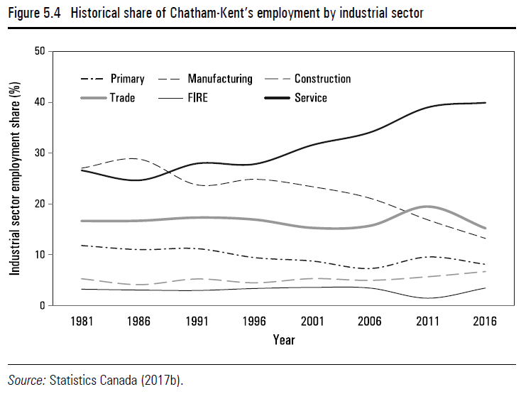
Caption:
Figure 5.4: Historical share of Chatham-Kent’s employment by industrial sector
Alt-text:
 | Primary | Manufacturing | Construction | Trade | FIRE | Service
1981 | 12 | 27 | 5 | 17 | 3 | 27
1986 | 11 | 29 | 4 | 17 | 3 | 25
1991 | 11 | 24 | 5 | 17 | 3 | 28
1996 | 9 | 25 | 4 | 17 | 3 | 28
2001 | 9 | 23 | 5 | 15 | 4 | 32
2006 | 7 | 21 | 5 | 16 | 3 | 34
2011 | 10 | 17 | 6 | 20 | 1 | 39
2016 | 8 | 13 | 7 | 15 | 3 | 40

The above illustration and its caption and alt-text appear in Hartt, Quietly Shrinking Cities: Canadian Urban Population Loss in an Age of Growth (Vancouver: UBC Press, 2021).

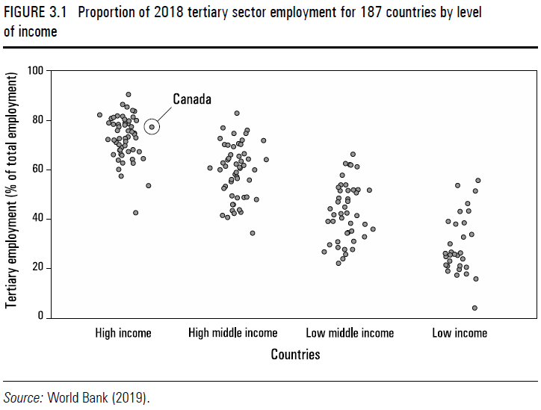
Caption:
Figure 3.1: Proportion of 2018 tertiary sector employment for 187 countries by level of income
Alt-text:
A graph depicting the proportion of tertiary employment (y-axis) of 187 countries categorized by their income level (x-axis). High-income countries have the highest proportion of tertiary employment, followed in hierarchical order by high middle–income countries, low middle–income countries, and low-income countries. Canada’s point is located in the top third of the high income countries.

The above illustration and its caption and alt-text appear in Hartt, Quietly Shrinking Cities: Canadian Urban Population Loss in an Age of Growth (Vancouver: UBC Press, 2021).

Sample Artwork (map)

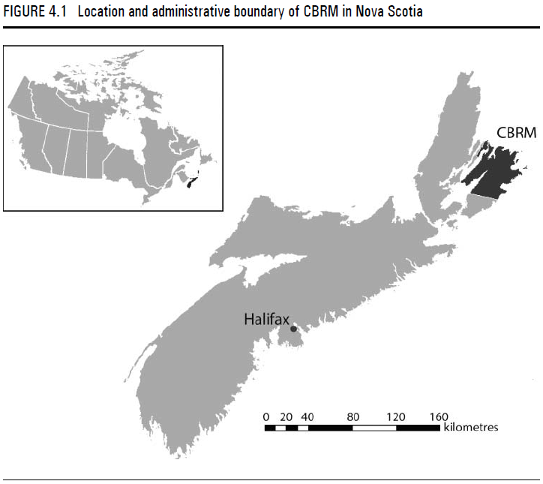
Caption:
Figure 4.1: Location and administrative boundary of CBRM in Nova Scotia
Alt-text:
The figure shows two maps. One is an inset map of Canada with the province of Nova Scotia highlighted to show its location within the country. The second is a map of Nova Scotia with Cape Breton Regional Municipality (CBRM) highlighted and labeled. The map of Nova Scotia also has a point and label denoting the provincial capital of Halifax.

The above illustration and its caption and alt-text appear in Hartt, Quietly Shrinking Cities: Canadian Urban Population Loss in an Age of Growth (Vancouver: UBC Press, 2021).

Sample Artwork (diagram)
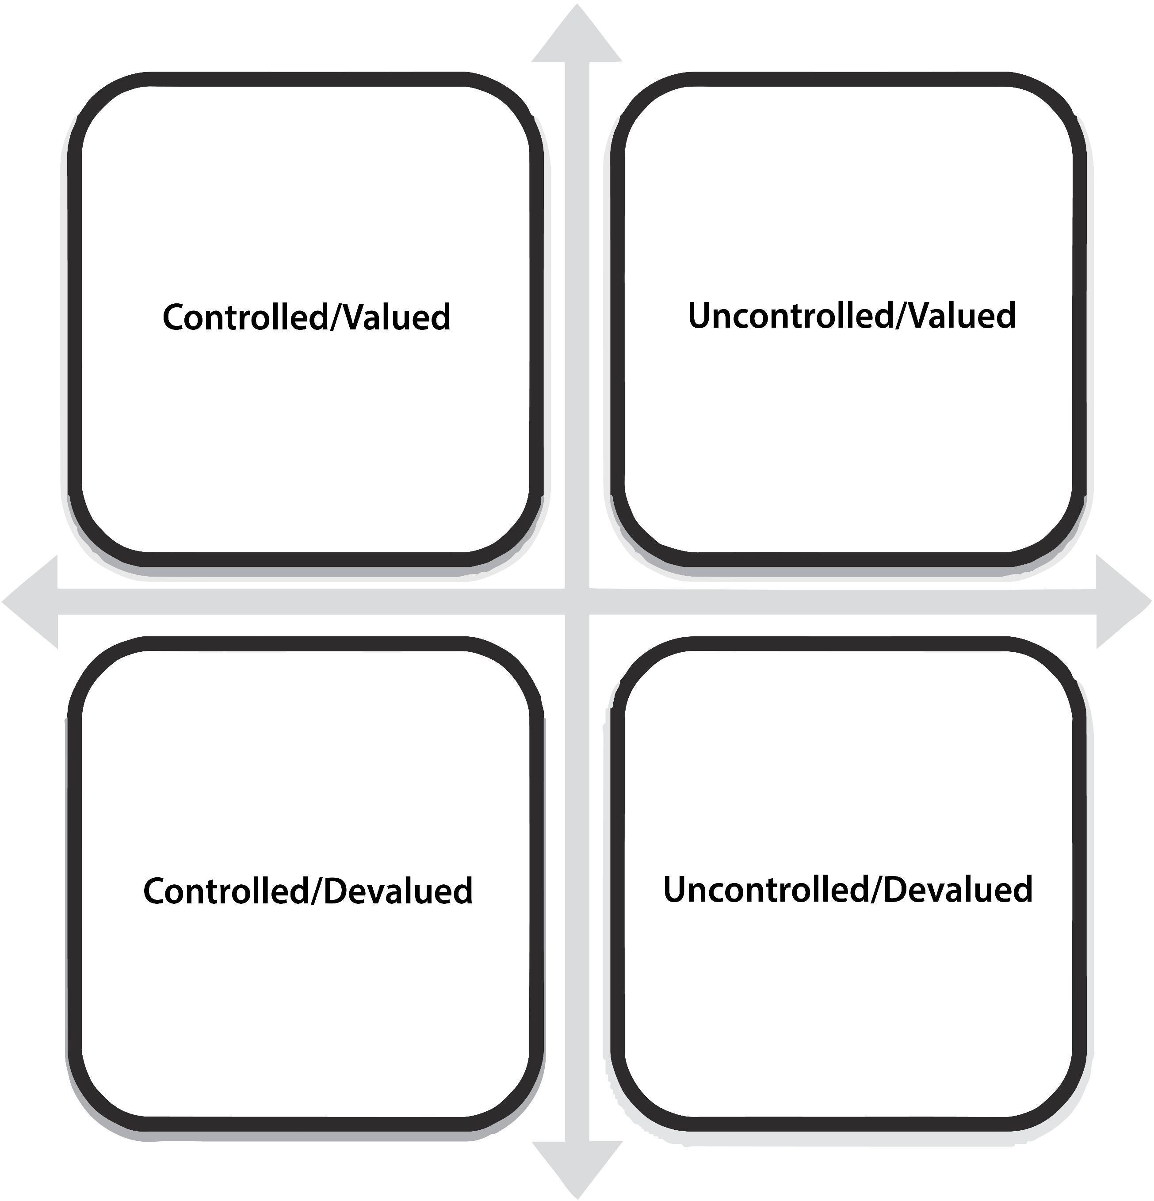
Caption:
Figure 8: Settler colonial attitudes to land
Alt-Text:
Four quadrants are laid out on an X axis from more controlled to less controlled and on a Y axis from more valued to less valued. Read clockwise from the upper left, the four quadrants thus have two characteristics each: “Controlled/Valued,” “Uncontrolled/Valued,” “Uncontrolled/Devalued,” and “Controlled/Devalued.”

The above illustration and its caption and alt-text appear in Barker, Making and Breaking Settler Space: Five Centuries of Colonization in North America (Vancouver: UBC Press, 2021).

Sample Artwork (photograph)
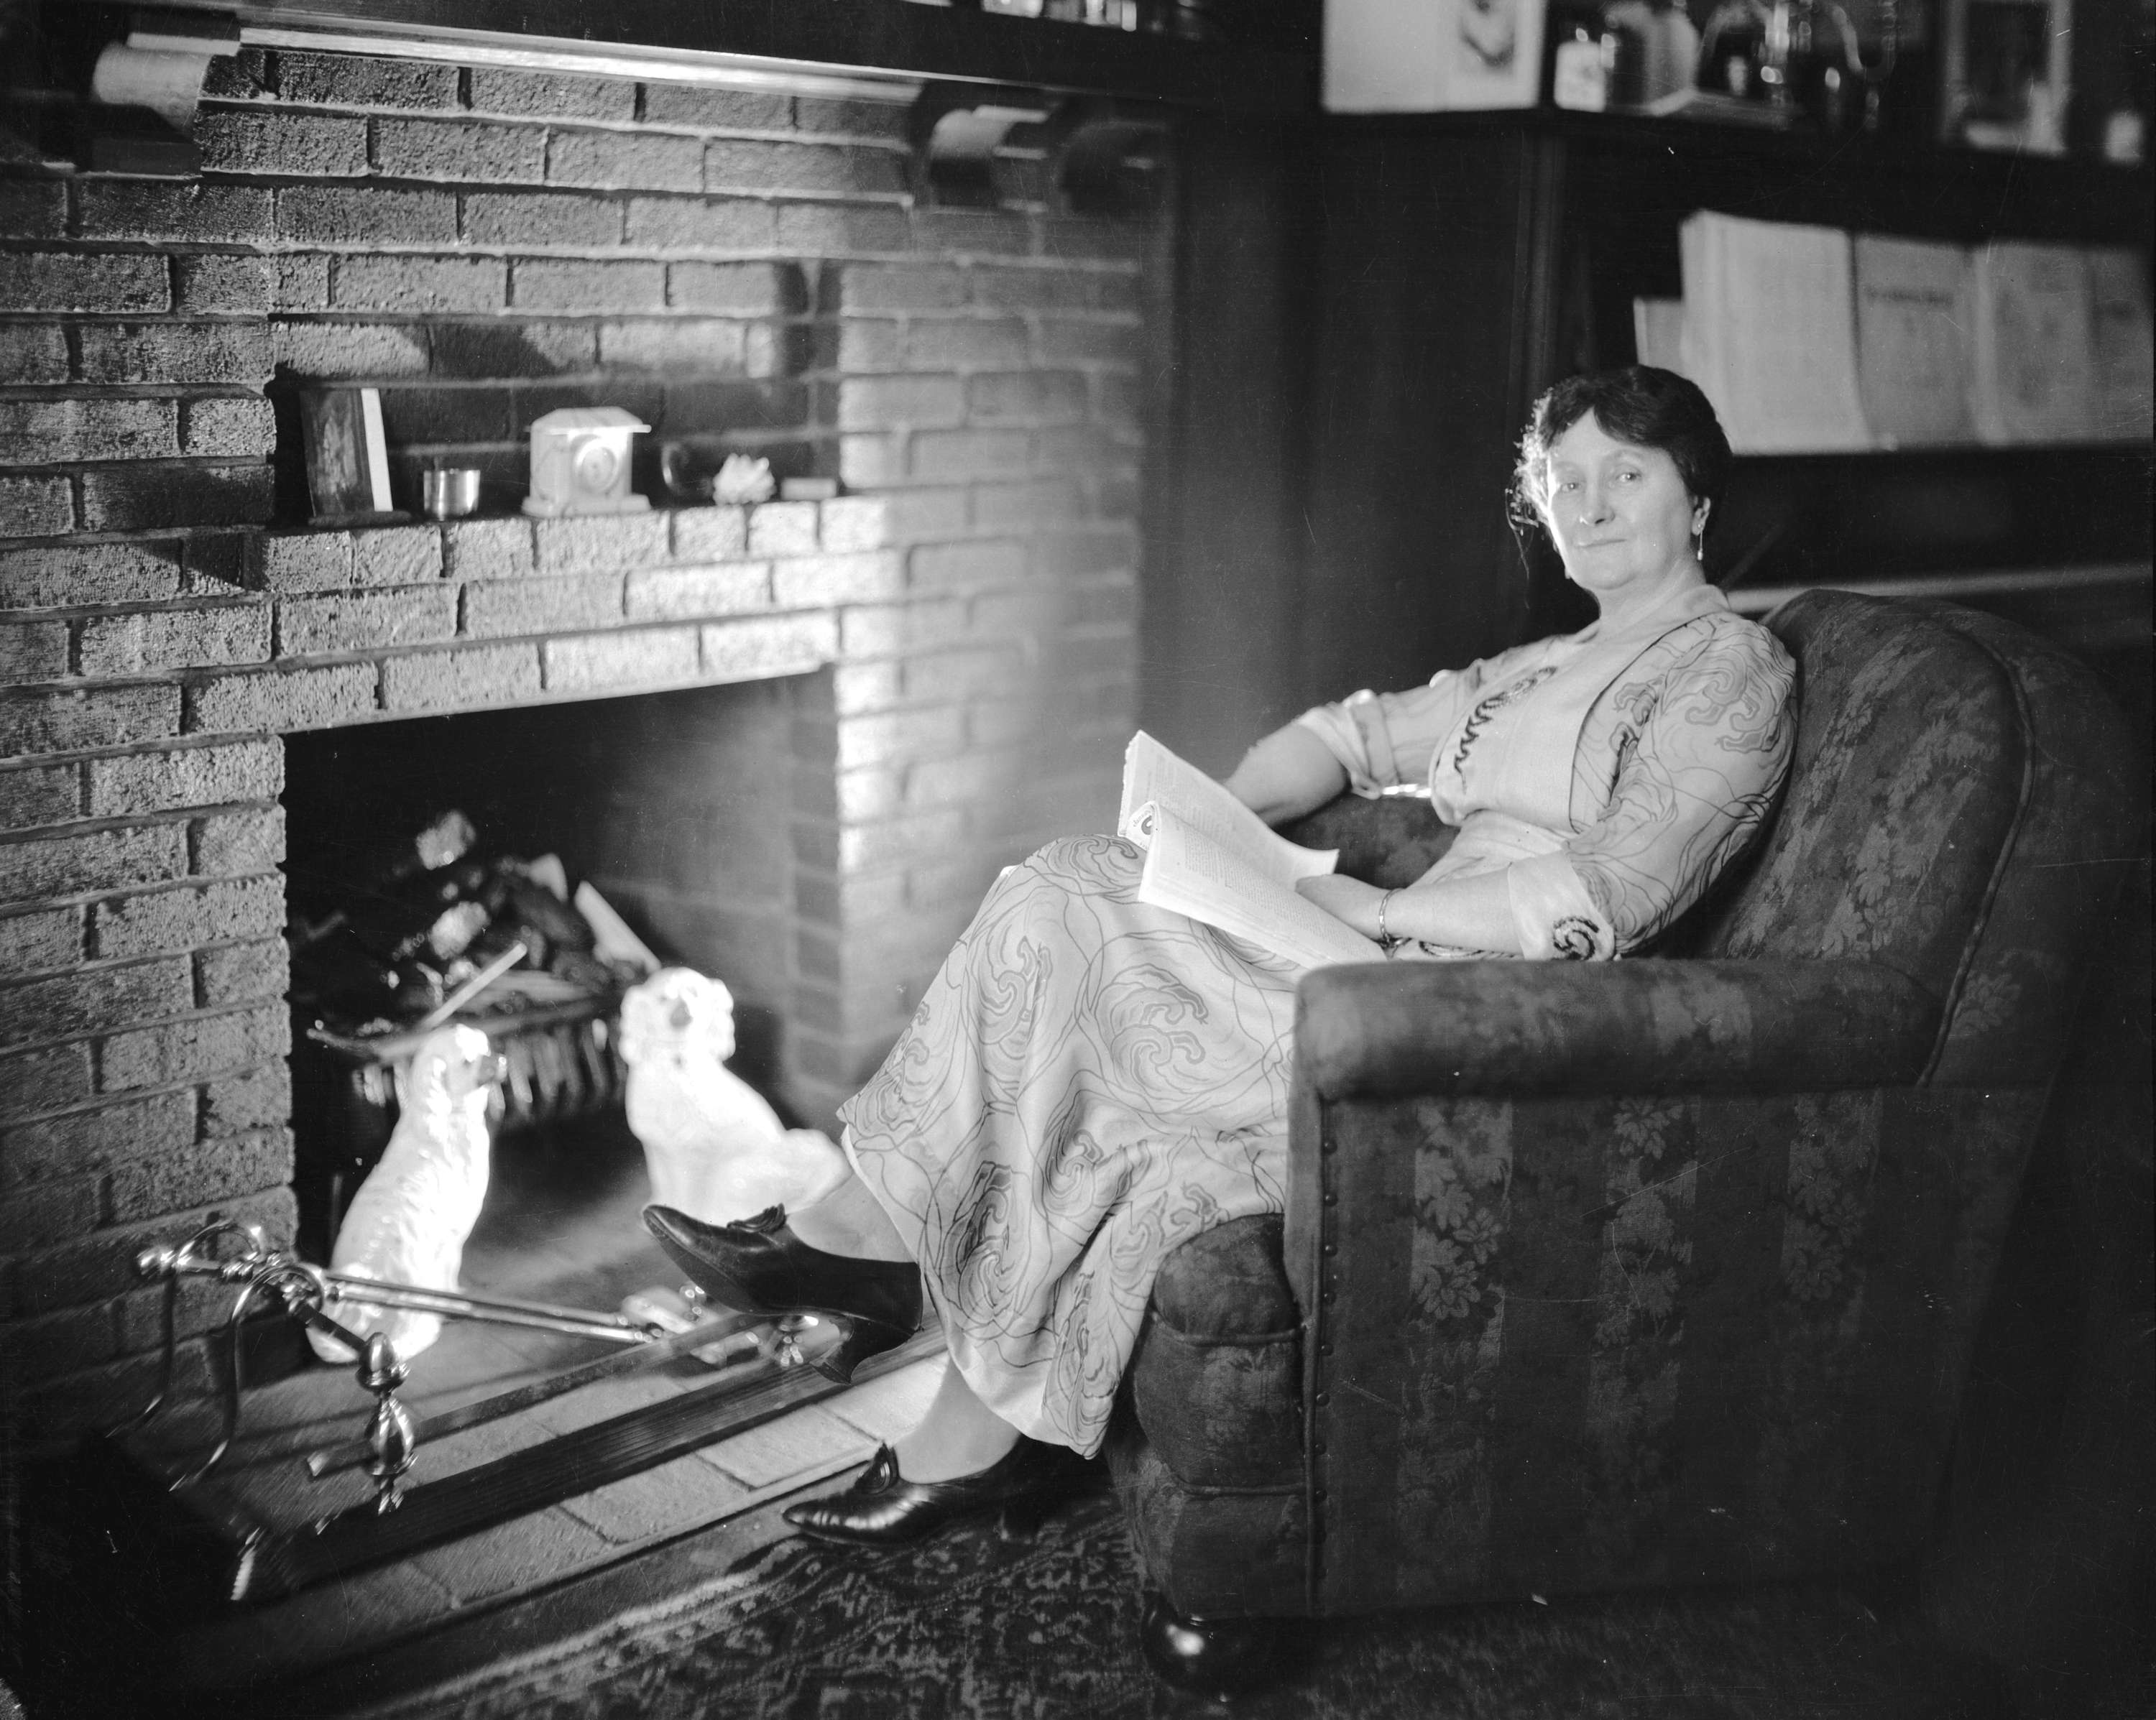
Caption:
Figure 5.5: Mary Ellen Spear Smith at home in a modest apartment
Alt-text:
A middle-aged White woman wearing an ankle-length dress sits in an armchair close to a fireplace. There is an open book on her lap. She appears maternal and unthreatening.

The above illustration and its caption and alt-text appear in Strong-Boag, A Liberal-Labour Lady: The Times and Life of Mary Ellen Spear Smith (Vancouver: UBC Press, 2021).

Sample Artwork (political cartoon)
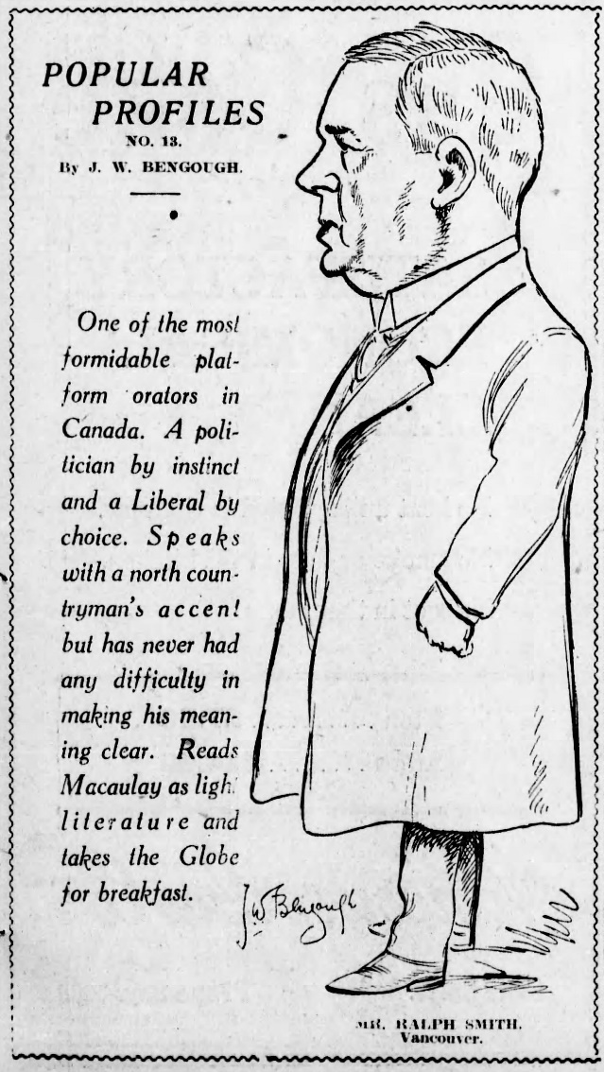
Caption:
Figure 4.4: Ralph Smith, 1916. | J.M. Bengough, “Popular Profiles,” Vancouver World, September 9, 1916.
Alt-text:
A political cartoon of an overweight man in profile, wearing a suit and an overcoat, identified as Mr. Ralph Smith of Vancouver. The text reads: “Popular Profiles No. 13, by J.W. Bengough. One of the most formidable platform orators in Canada. A politician by instinct and a Liberal by choice. Speaks with a north countryman’s accent but has never had any difficulty in making his meaning clear. Reads Macaulay as light literature and takes the Globe for breakfast.”

The above illustration and its caption and alt-text appear in Strong-Boag, A Liberal-Labour Lady: The Times and Life of Mary Ellen Spear Smith (Vancouver: UBC Press, 2021).

